Bedtime Buddy
From Mosswood Connections, http://mosswoodconnections.com/activities/sensory-regulation-activities/bedtime-buddy/
Warning: This project contains small parts and is not recommended for children under the age of three.

While reading the deliciously sweet Don’t Turn the Page by Rachelle Burk, illustrated by Julie Downing, I was reminded of our own bedtime routine with our daughter. I became inspired to make some of our own Bedtime Buddies for our nighttime routine. Our bedtime routine is full of cuddles and books. Once she finally makes it to her own bed she needs all her favorite “friends” surrounding her. She loves all her stuffed friends but there is always that one special buddy that needs to be held close.
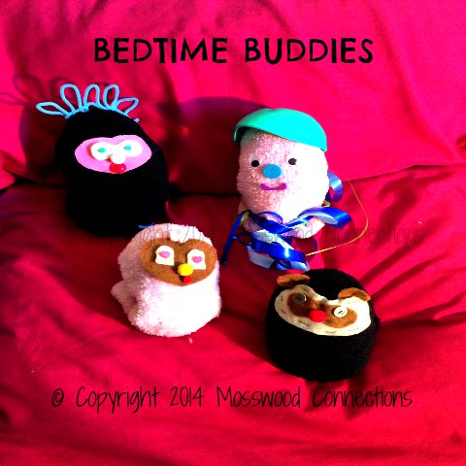

Make your own sweet smelling Bedtime Buddy and it will soon be your child’s favorite stuffed friend!

Materials:
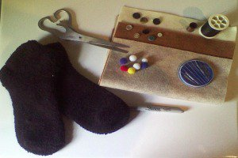o
o Socks – we prefer to use fuzzy socks.
o Felt
o Needle & Thread
o Scissors
o Beans or Stuffing (not pictured)
o Pompoms, buttons or other decorations.
o Lavender Oil (not pictured)
Instructions:
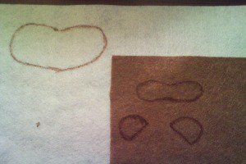
• Trace the outline for the eyes, nose, smile or whatever you want on your Bedtime Buddy.
• Cut out the felt pieces.
• Layer them on the sock and sew them on. You can use hot glue but it might be bumpy and not so fun to cuddle.
• Add any of decorations such as the buttons for eyes.
• Once you have finished with the decorations fill the sock with your beans or stuffing. Beans will more satisfying than stuffing. If you don’t have beans you can substitute with something else; I used black eye peas.
• Add a few drops of the lavender oil.
• I used a rubber band to hold the sock closed and then sewed up the opening. Remember to remove the rubber band.
• You can warm the Bedtime Buddy in the microwave (if you haven’t added anything metallic) by heating for 15 seconds.
• You can also keep your Bedtime Buddy in the refrigerator and use it as a cool compress for when your child gets hurt.

These Bedtime Buddies would also make great fidget toys. You can substitute mint oil for the lavender oil if you want to “wake up” the children.

